Wellness Chess Tour GP4.
Hotel Famulus **** Győr
-International Grand Prix Competition Series-
- Grand Prix competition 4th station –
- 17-20. April –
- with discounted thermal spa ticket in the Győr Spa -
The competition’s goal: Providing an opportunity to participate in competitions and gain rating points.
Information that you have to know about our Grand Prix system:
I would like to reward your loyalty! On an annual level, in our competition series which consisting
12 stations by the actual station is 1-10. with our ranking, we get GP points, and with it, we have a good chance to win the +210,000 HUF total premium reward awarded at our final competition in December 2025! Those who participate at least 6 stations will be included in the absolute order of the GP table, and the final winners of this (1st-5th place in the table) will be awarded at our final competition in December 2025!
Anyone who participates in at least 10 of the 12 stations will receive a GUARANTEED Wellness weekend in a hotel of their choice for 2 people! (The 3 wellness weekends will be awarded to the three players who complete 10 stations the fastest and their partner/companion).
Location: Conference Room in the Hotel Famulus **** Győr
9027. Gyor, Budai street 4.
Competition’s date: 2025. 17- 20. April (Thursday - Sunday)
Schedule: Opening ceremony: 17. April 10:50
1st and 2nd rounds: 17. April 11:00 and 16:00
3rd and 4th rounds: 18. April 9.00 and 15.00
5th and 6th rounds: 19. April 9.00 and 15.00
Blitz competition: 19. April 19:30
7th round: 20. April 9.00
The closing ceremony is right after the end of the last round!
Competition’s form: 7 rounds, Swiss system, Open, no ELO restriction
Organizer: Jozsef Jeszenszky, registration: sporty207@gmail.com
Time limit: 1,5 hour – 1,5 hour + 30 sec per move bonus time
Entry fee: Above 2200 ELO: HUF 9.000, 2199 – 2100 HUF 12.000, under 2100 ELO: HUF 13.000, and free for GM, IM, WGM.
Discount: Those who participate in at least 6 stations will receive a HUF 2000 discount on the entry fee at each location from the 7th station in 2025!
If at least 5 paid people from a chess association are registered for our tournament, they will receive a fee discount per person! In the case of an entry fee of HUF 13,000, the player's entry fee will be HUF 11,000, if entry fee of HUF 12,000, it will be HUF 10,000 and if it is HUF 9,000, it will be HUF 8,000!
Entry information: Entry deadline: 16th April 2025. to the sporty207@gmail.com email address. All registrations will be confirmed. You can only enter the competition with a valid license or HPL for 2025.
Prize: Prize base: HUF 250.000 !!! (guaranteed with at least 50 participants)
- HUF 100.000, 2. HUF 60.000, 3. HUF 35.000, 4. HUF 25.000, 5. HUF 20.000, 6. HUF 10.000.
- HUF 100.000, 2. HUF 60.000, 3. HUF 40.000, 4. HUF 30.000, 5. HUF 20.000. Special award for the best young competitor, the best competitor from Gyor-Moson-Sopron County and the best competitor who is at least 60 years old and also the best woman (at least 3 players). Prizes (5-5000HUF) for the best competitor 1600-1800 ELO points and 1800-2000 ELO points. Prizes are not split. Taxes and contributions are according to Hungarian law!
Tiebreak: 1. Corrective Buchholz; 2. Buchholz 3. Progressive

Accommodation, special offer:
Hotel Famulus *** Győr
Service: generous buffet breakfast and dinner (dinner is extra fees)
The reservation is made by Jozsef Jeszenszky, tournament director, by email!
Meals: ample buffet breakfast, dinner with half board**
Discounted HUF 33,500 / room for 1 person / night with buffet breakfast
Discounted HUF 38,000 / room for 2 people / night with buffet breakfast
Discounted HUF 45,000 / room for 2 adults and 1 child / night
With buffet breakfast - a limited number of this room type
Discounted HUF 56,500 / family room for 2 adults and 2 children / night
With buffet breakfast - a limited number of this room type
The offer is valid for booking a minimum of 3 nights. For a shorter stay, contact the competition director Jozsef Jeszenszky!

Children's discount: under 12 years old: in a room with 2 adults, free of charge when using existing beds, we provide a 50% discount on the main meal.
Over 12 years old: adult prices apply.

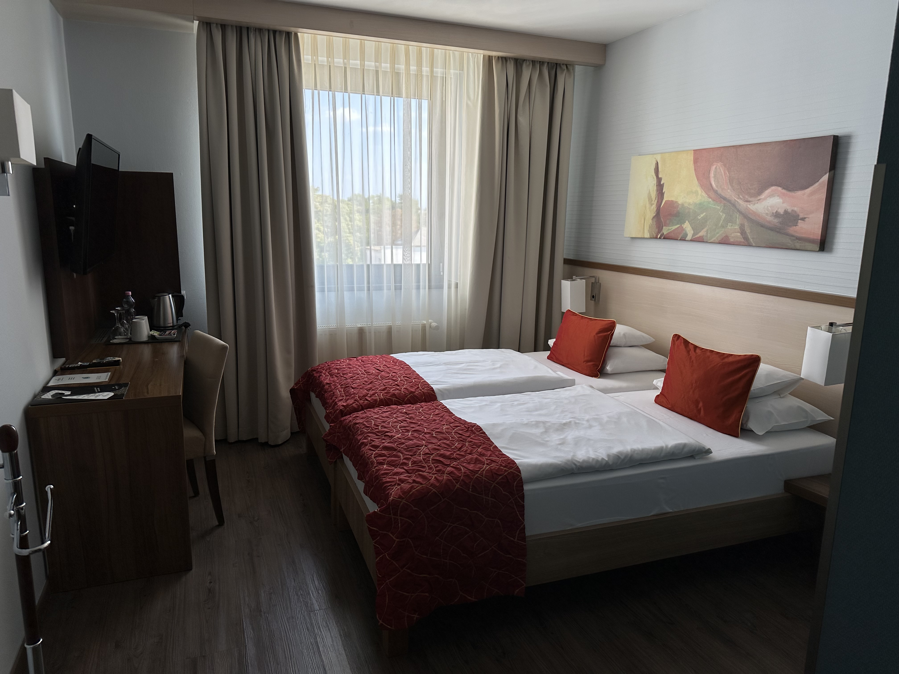

Lunch option:
• a la carte
• daily menu / bistro HUF 2,200 / HUF 2,400 + 10% service fee

**Dinner option:
• a la carte
• half board HUF 5,490 + 10% service fee

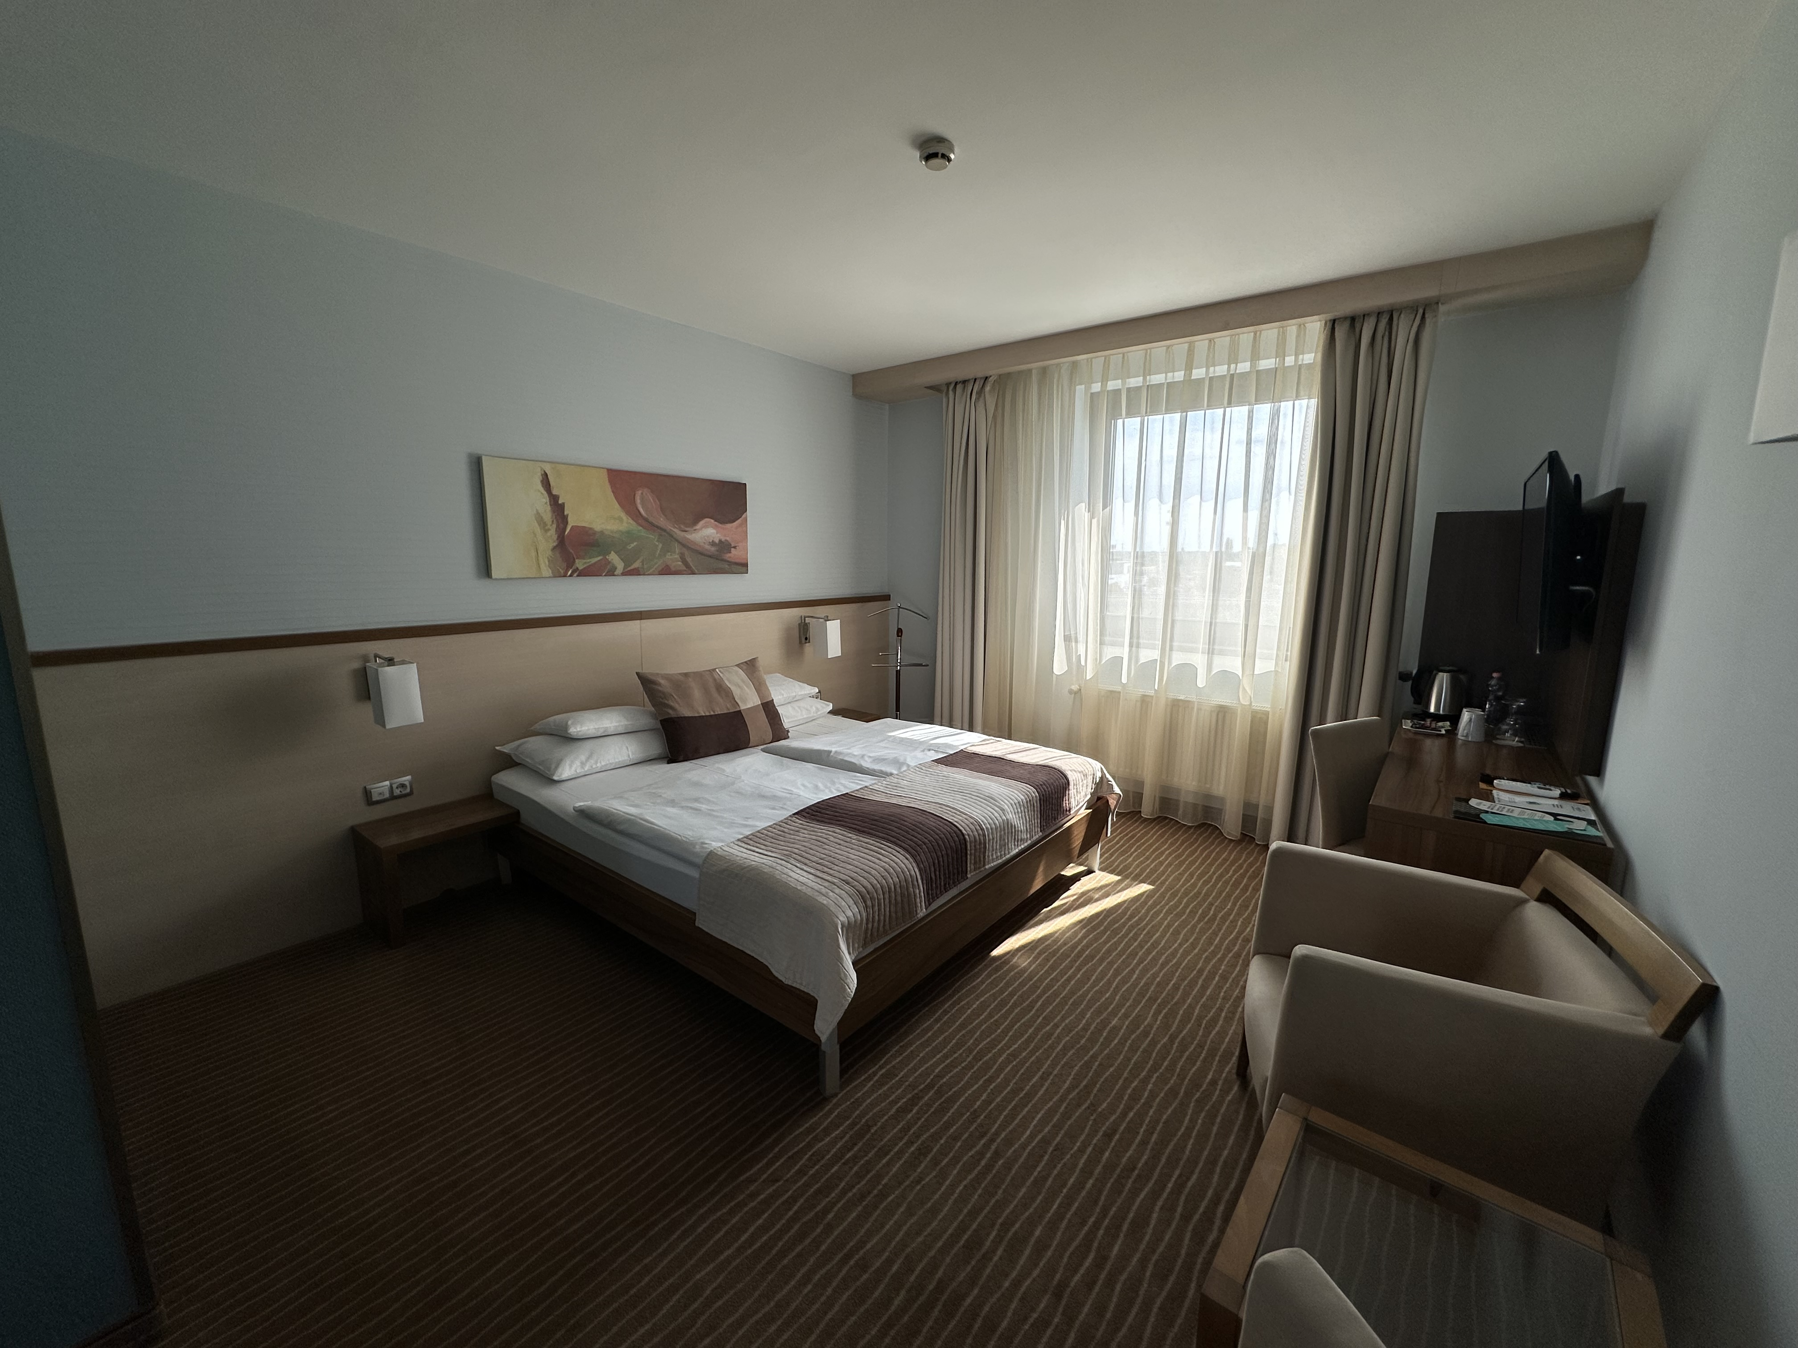

The above price includes the following:

Accommodation in a double room for 1 or 2 people

- number combination room safe,
- hairdryer in the bathroom,
- wireless Internet
- parking in the hotel's 176-space parking lot
- tea and coffee making in the room
- toilet preparation in the room
- VAT (The accommodation price does not include tourist tax).

Use of the Győr Experience and Spa at a discount, inquire about tickets on the spot during registration with the competition organizer Jozsef Jeszenszky!
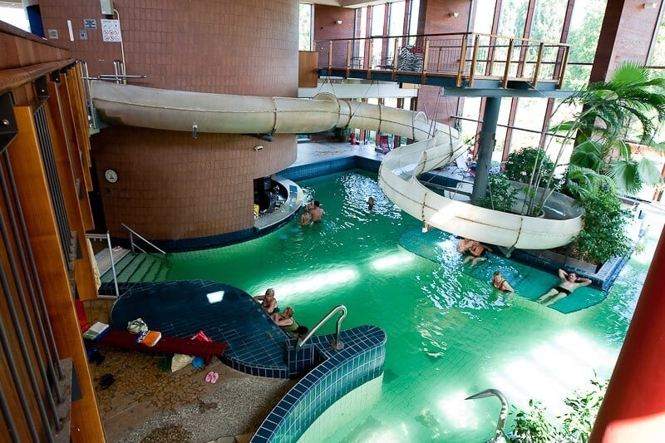

Pictures of the competition venue, the wellness area, the restaurant, the rooms, and the Hotel Famulus can be found on the following website: https://famulushotel.hu/galeria

We reserve the right to make changes to the competition notice.

We welcome everyone to the competition!

Registration, information:​
Jozsef Jeszenszky sporty207@gmail.com +36 30 640 3361
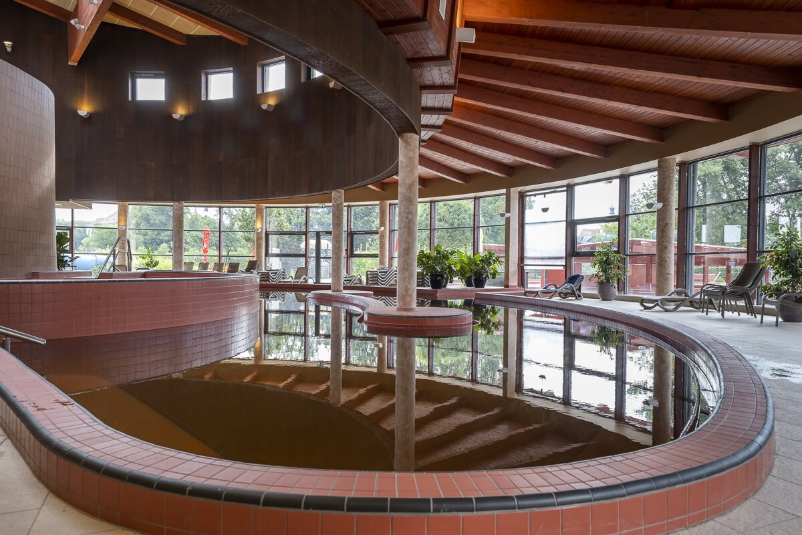
www.wellnesschesstour.com https://www.facebook.com/wellnesschesstour

