Wellness Chess Tour GP3.
Hotel Laterum *** Pécs
-International Competition Series-
- Grand Prix competition 3rd station –
- March 6 – 9. -
The competition’s goal: Providing an opportunity to participate in competitions and gain rating points.
Information that you have to know about our Grand Prix system:
I would like to reward your loyalty! On an annual level, in our competition series which consisting
12 stations by the actual station is 1-10. with our ranking, we get GP points, and with it, we have a good chance to win the +210,000 HUF total premium reward awarded at our final competition in December 2025! Those who participate at least 6 stations will be included in the absolute order of the GP table, and the final winners of this (1st-5th place in the table) will be awarded at our final competition in December 2025!
Anyone who participates in at least 10 of the 12 stations will receive a GUARANTEED Wellness weekend in a hotel of their choice for 2 people! (The 3 wellness weekends will be awarded to the three players who complete 10 stations the fastest and their partner/companion).
Location: Conference Room in Hotel Laterum*** Pécs
7633. Pécs, Hajnóczy street 37-39.
Competition’s date: 2025. March 6. – March 9. (Thursday - Sunday)
Schedule: Opening ceremony: March 6. 10:50
1st and 2nd rounds: March 6. 11:00 and 16:00
3rd and 4th rounds: March 7. 9.00 and 15.00
5th and 6th rounds: March 8. 9.00 and 15.00
Blitz competition: March 8. 19:30
7th round: March 9. 9.00
The closing ceremony is right after the end of the last round!
Competition’s form: 7 rounds, Swiss system, Open, no ELO restriction
Organizer: Jozsef Jeszenszky, registration: sporty207@gmail.com
Time limit: 1,5 hour – 1,5 hour + 30 sec per move bonus time
Entry fee: Above 2200 ELO: HUF 9.000, 2199 – 2100 HUF 12.000, under 2100 ELO: HUF 13.000, and free for GM, IM, WGM.
Discount: Those who participate in at least 6 stations will receive a HUF 2000 discount on the entry fee at each location from the 7th station in 2025!
If at least 5 paid people from a chess association are registered for our tournament, they will receive a fee discount per person! In the case of an entry fee of HUF 13,000, the player's entry fee will be HUF 11,000, if entry fee of HUF 12,000, it will be HUF 10,000 and if it is HUF 9,000, it will be HUF 8,000!
Entry information: Entry deadline: 5th March 2025. to the sporty207@gmail.com email address. All registrations will be confirmed. You can only enter the competition with a valid license or HPL for 2025.
Prize: Prize base: HUF 250.000 !!! (guaranteed with at least 50 participants)
- HUF 100.000, 2. HUF 60.000, 3. HUF 35.000, 4. HUF 25.000, 5. HUF 20.000, 6. HUF 10.000.
- HUF 100.000, 2. HUF 60.000, 3. HUF 40.000, 4. HUF 30.000, 5. HUF 20.000. Special award for the best young competitor, the best competitor from Baranya County and the best competitor who is at least 60 years old and also the best woman (at least 3 players). Prizes (5-5000HUF) for the best competitor 1600-1800 ELO points and 1800-2000 ELO points. Prizes are not split. Taxes and contributions are according to Hungarian law!
Tiebreak: 1. Corrective Buchholz; 2. Buchholz 3. Progressive

Accommodation, special offer:
Hotel Laterum *** Pécs
Service: generous buffet breakfast and dinner (dinner is extra fees)

Room price for 1 person/night/room, for 2 persons/night/room, for 3 persons/night/room
Laterum eco room HUF 13,000 HUF 23,000 HUF 30,000

4-star room HUF 19,000 HUF 28,000 HUF 39,000

3-star room HUF 16,000 HUF 26,000 HUF 36,000

Half board price: HUF 5500/person/night (3 meals dinner)
The above price includes the following:
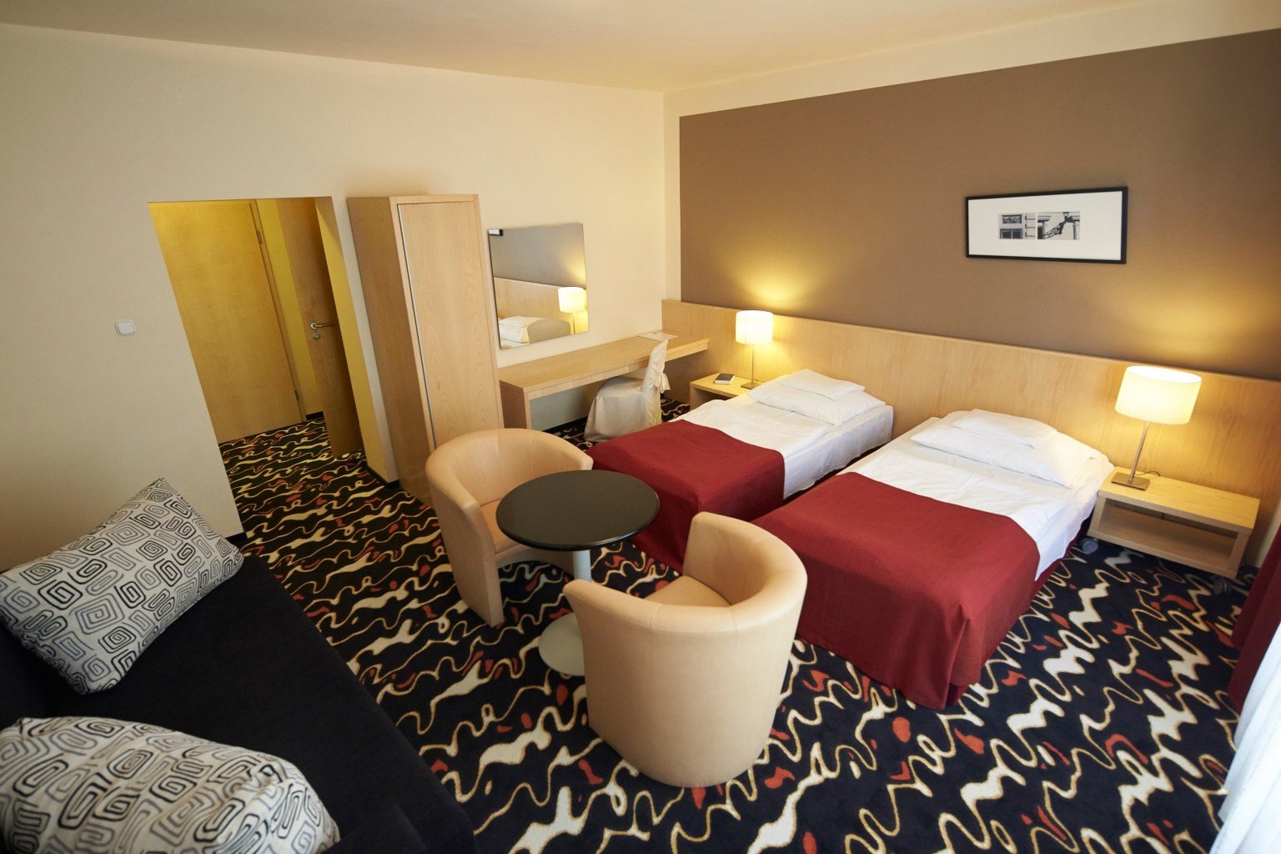
Breakfast buffet, use of the wellness area (4x5 m pool, whirlpool, Finnish sauna, infrared sauna, steam cabin), Use of WIFI and parking
Our wellness department is open every day from 2:00 p.m. to 10:00 p.m.
To use our wellness services, we provide a bathrobe, towel and bath towel.
Child discount:
- Free up to 2 years old
- 50% for ages 2-12
Cancellation policy:
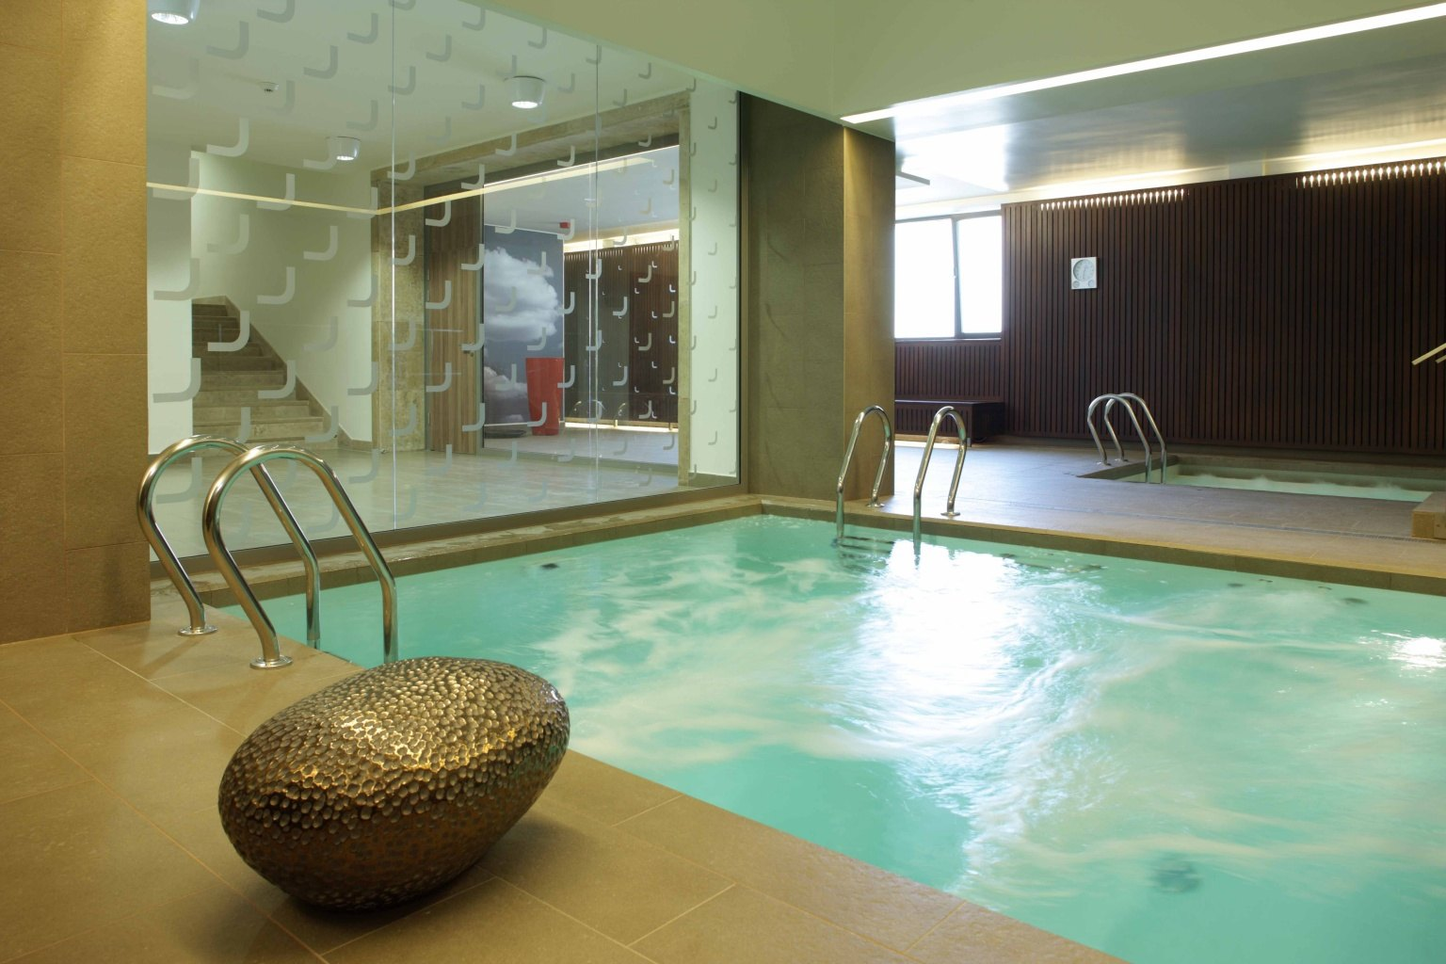
14 days before arrival: penalty-free
7-13 days before arrival: 50% of the gross amount of the ordered services
4-6 days before arrival: 70% of the gross amount of the ordered services
2-3 days before arrival: 85% of the gross amount of the ordered services
1-0 days before arrival or in case of no show: the ordered services are gross 100% of its amount
You can find photos about the place of the competition, the wellness, the restaurant, the rooms on the website of Hotel Laterum Pécs:
https://laterumhotel.hu/hu/kepgaleria

You can check-in and book the rooms 14 o’clock at the day of the competition, and have to leave until 10 o’clock at the last day.

We reserve the rights of the change in the notice of the competition.

We wait everyone to the event with love!
Nomination, information:​
Jozsef Jeszenszky sporty207@gmail.com +36 30 640 3361
www.wellnesschesstour.com https://www.facebook.com/wellnesschesstour

