Wellness Chess Tour competition series
Grand Prix 2025. GP2.
Hotel Kager**** Harkany
- with wonderful indoor spa and green area, excursion opportunities with half board, and with thermal spa entrance tickets –
- Grand Prix competition 2nd station –
- 6-9. February 2024. -
The competition’s goal: Providing an opportunity to participate in competitions and gain rating points.
Information that you have to know about our Grand Prix system:
I would like to reward your loyalty! On an annual level, in our competition series which consisting
12 stations by the actual station is 1-15. with our ranking, we get GP points, and with it, we have a good chance to win the +210,000 HUF total premium reward awarded at our final competition in December 2025! Those who participate at least 6 stations will be included in the absolute order of the GP table, and the final winners of this (1st-5th place in the table) will be awarded at our final competition in December 2025!
Anyone who participates in at least 10 of the 12 stations will receive a GUARANTEED Wellness weekend in a hotel of their choice for 2 people!
Location: Conference Room in Hotel Kager**** Harkany
7815. Harkany, Szent Istvan street 50-52. www.hotel-kager.hu
Competition’s date: 2025. February 6. – February 9. (Thursday - Sunday)
Schedule: Opening ceremony: February 6. 10:50
1st and 2nd rounds: Febuary 6. 11:00 and 16:00
3rd and 4th rounds: February 7. 9.00 and 15.00
5th and 6th rounds: February 8. 9.00 and 15.00
Blitz competition: February 8. 19:30
7th round: February 9. 9.00
The closing ceremony is right after the end of the last round!
Competition’s form: 7 rounds, Swiss system, Open, no ELO restriction
Organizer: Jozsef Jeszenszky, registration: sporty207@gmail.com
Time limit: 1,5 hour – 1,5 hour + 30 sec per move bonus time
Entry fee: Above 2200 ELO: HUF 9.000, 2199 – 2100 HUF 12.000, under 2100 ELO: HUF 13.000, and free for GM, IM, WGM, WIM.
Discount: Those who participate in at least 6 stations will receive HUF2000 discount on the entry fee at each location from the 7th station in 2025!
If at least 5 people from a chess association are registered for our tournament, they will receive a HUF 2000 fee discount per person!
Entry information: Entry deadline: 4th February 2025 to the sporty207@gmail.com email address. All registrations will be confirmed. You can only enter the competition with a valid license or HPL for 2025.
Prize: Prize base: HUF 250.000 !!! (guaranteed with at least 50 participants)
- HUF 100.000, 2. HUF 60.000, 3. HUF 35.000, 4. HUF 25.000, 5. HUF 20.000, 6. HUF 10.000. Special award for the best young competitor, the best competitor from Baranya County and the best competitor who is at least 60 years old and also the best woman (at least 5 players/category). Plus, prizes (5-5000HUF) ELO 0-1800 and ELO 1800-2000 best player. Prizes are not split. Taxes and contributions are according to Hungarian law!
Tiebreak: 1. Corrective Buchholz; 2. Buchholz 3. Progressive
Accommodation, special offer:
Hotel Kager**** Harkany
Service: half boarded, generous buffet breakfast and dinner
Accommodation / price with half board:
The price of 2 person with double room with half board: HUF 125,400. / 2 people / 3 nights. (06-09. February 2025)
Offer for 1 person is HUF 65,700/person/ 3 night with half board! (06-09. February 2025)
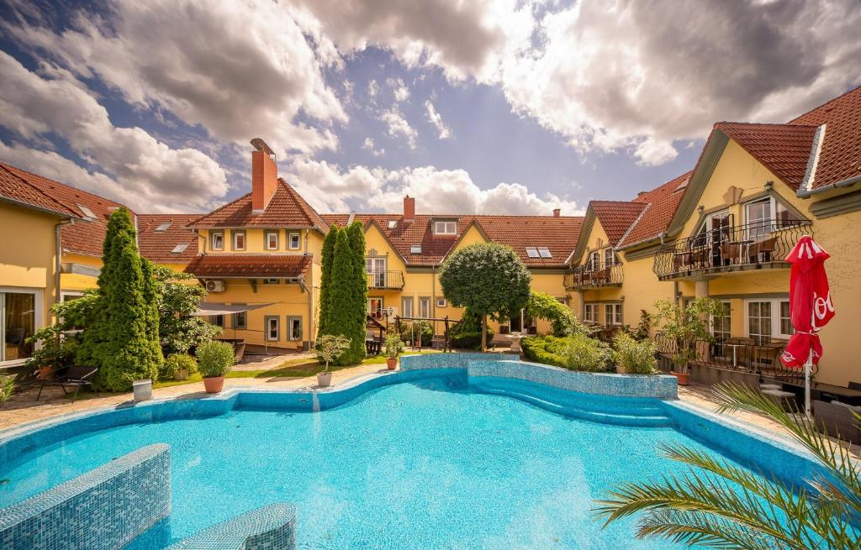
Children discount: 0-5 years old free! 5-12 years old 50% discount!

Hotel payment method: cash, bank card, Széchenyi leisure card (SZÉP card)
Our package offer includes the following services:
- Accommodation
- Half board (buffet breakfast + buffet dinner)
- Unlimited use of the wellness area!
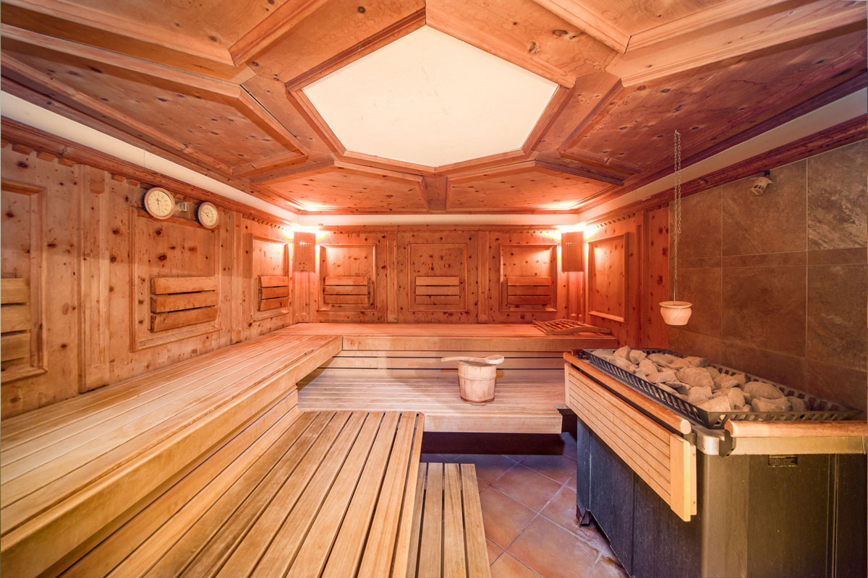
- Use of indoor hot tubs
- Sauna use (infrared, Finnish, aroma)
- Steam cabin
- Bathrobes and sauna towels
- Fitness room use
- Internet (wifi) use
- Closed parking
- Wellness fee for external guests: HUF 2,500/person
Tourist tax is not included in the price.
Foosball, table tennis and use of the gym are also available on site free of charge. A play corner is available for children free of charge.

Photos about the place of competition: https://hotel-kager.hu/hotel/galeria

We reserve the rights of the change in the notice of the competition.

We are waiting for everyone to the event with love!

Registration, information: ​
Jozsef Jeszenszky
Tournament director
+36 30 640 3361 sporty207@gmail.com
www.wellnesschesstour.com https://www.facebook.com/wellnesschesstour

