Wellness Chess Tour GP12 station
Hotel Bellevue*** Esztergom
- with Thermal Spa wellness and half board –
- with A and B group -
- Grand Prix competition 12th station –
- 19-22. December -
The competition’s goal: Providing an opportunity to participate in competitions and gain rating points.
Information that you have to know about our Grand Prix system:
I would like to reward your loyalty! On an annual level, in our competition series which consisting
12 stations by the actual station is 1-10. with our ranking, we get GP points, and with it, we have a good chance to win the +210,000 HUF total premium reward awarded at our final competition in December 2024! Those who participate at least 6 stations will be included in the absolute order of the GP table, and the final winners of this (1st-5th place in the table) will be awarded at our final competition in December 2024!
Anyone who participates in at least 10 of the 12 stations will receive a GUARANTEED Wellness weekend in a hotel of their choice for 2 people! (The 3 wellness weekends will be awarded to the three players who complete 10 stations the fastest and their partner/companion).
Location: Conference Room in Hotel Bellevue*** Esztergom
2500. Esztergom, Őrtorony street 49.
Competition’s date: 2024. 19-22. December (Thursday - Sunday)
Schedule: Opening ceremony: 19. December 10:50
A & B group starting time: 1st and 2nd rounds: 19. December 11:00 and 16:00
3rd and 4th rounds: 20. December 9.00 and 15.00
5th and 6th rounds: 21. December 9.00 and 15.00
Blitz competition: 21. December 19:45
7th round: 22. December 9.00
The closing ceremony is right after the end of the last round!
Competition’s form: 7 rounds, Swiss Open with A&B group (B group under 1800 ELO)
Organizer: Jozsef Jeszenszky sporty207@gmail.com
Time limit: 1,5 hour – 1,5 hour + 30 sec per move bonus time
Entry fee: Above 2200 ELO: HUF 9.000, 2199 – 2100 HUF 11.000, under 2100 ELO: HUF 12.000, and free for GM, IM, WGM and above ELO 2400
In B group (under 1800 ELO) the entry fee is HUF 8000.
If somebody want to start in the A group, it is possible HUF 3000 extra fee and maximum 50ELO points difference.
Discount: Those who participate in at least 6 stations will receive a HUF2000 discount on the entry fee at each location from the 7th station in 2024!
If at least 5 paid people from a chess association are registered for our tournament, they will receive a fee discount per person! In the case of an entry fee of HUF 12,000, the player's entry fee will be HUF 10,000, if entry fee of HUF 11,000, it will be HUF 9,000 and if it is HUF 9,000, it will be HUF 8,000! Discounts cannot be combined!
Entry information: Entry deadline: 17th December 2024. to the sporty207@gmail.com email address. All registrations will be confirmed. You can only enter the competition with a valid license or FRD for 2024.
Prize: Prize base: HUF 320.000 !!! (guaranteed with at least 50 participants)
A group: 1. HUF 100.000, 2. HUF 60.000, 3. HUF 35.000, 4. HUF 25.000, 5. HUF 20.000, 6. HUF 10.000.
B group: 1. HUF 30.000, 2. HUF 20.000, 3. HUF 20.000 value giftcard
In the main competiton Special award for the best young competitor, the best competitor from Komarom-Esztergom County and the best competitor who is at least 60 years old and also the best woman (at least 3 players). Prizes are not split. Taxes and contributions are according to Hungarian law!
Tiebreak: 1. Corrective Buchholz; 2. Buchholz 3. Progressive
Extraordinary offer: Bellevue Conference & Wellness Hotel*** Esztergom
Meals: half board, with ample buffet breakfast and dinner
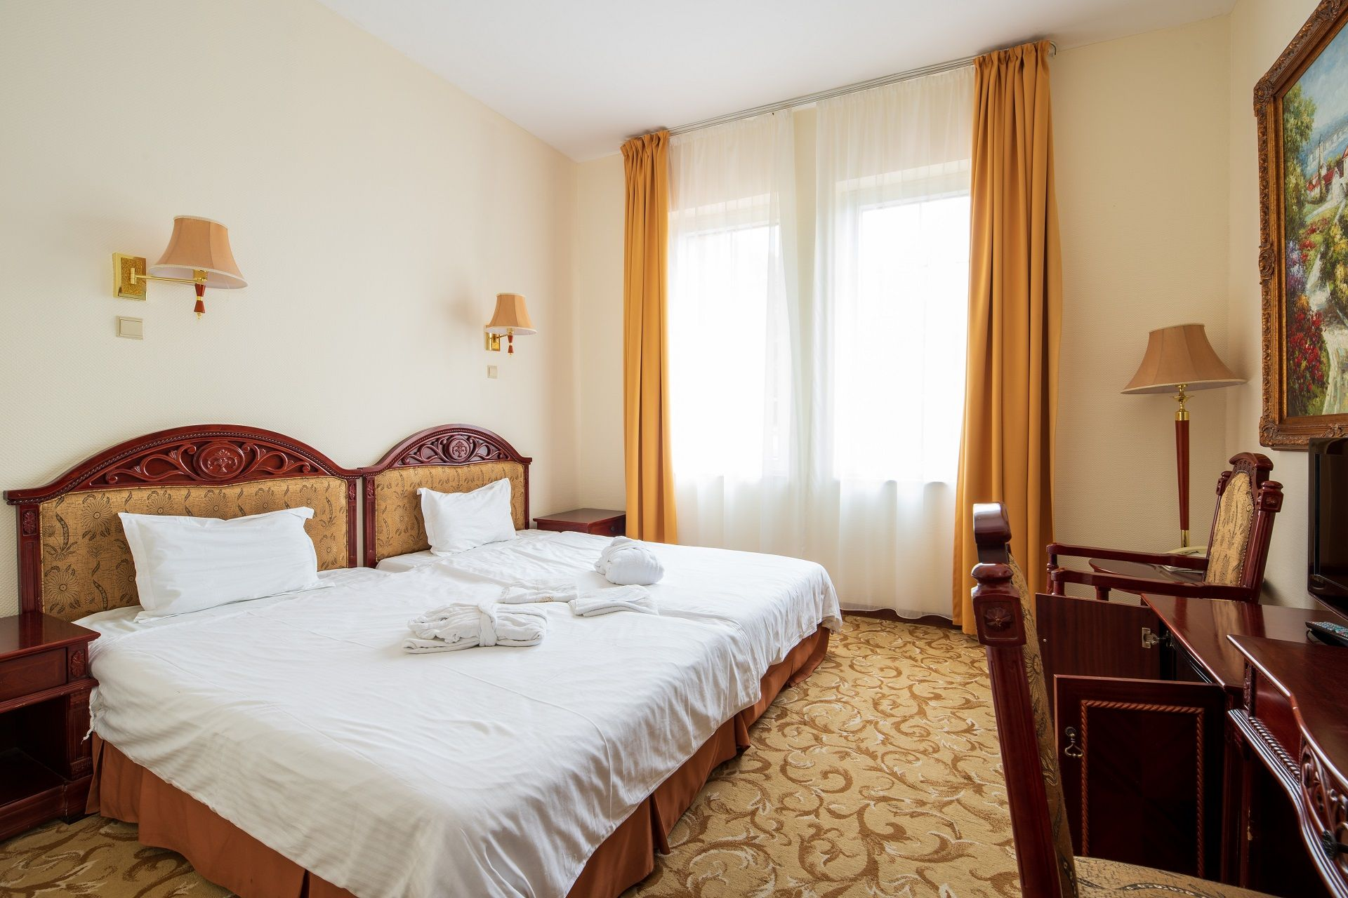
Room rates:
For a period of 4 days/3 nights
HUF 19,990/person/night
for 1 person in a standard single room: HUF 19,990 / person / night (LIMITED!)
for 1 person in a standard double room: HUF 27,900 / person / night
Discount for children:
o free for ages 0-3
o 4-12 years old HUF 6,200/person/night on an extra bed
The above price includes the following:
• accommodation with half board, buffet breakfast and dinner
• use of the wellness center steam cabin, salt cabin, aroma chamber, Finnish and bio sauna, jacuzzi,
• Experience pool, warm water relaxation pool, children's pool, sunbeds
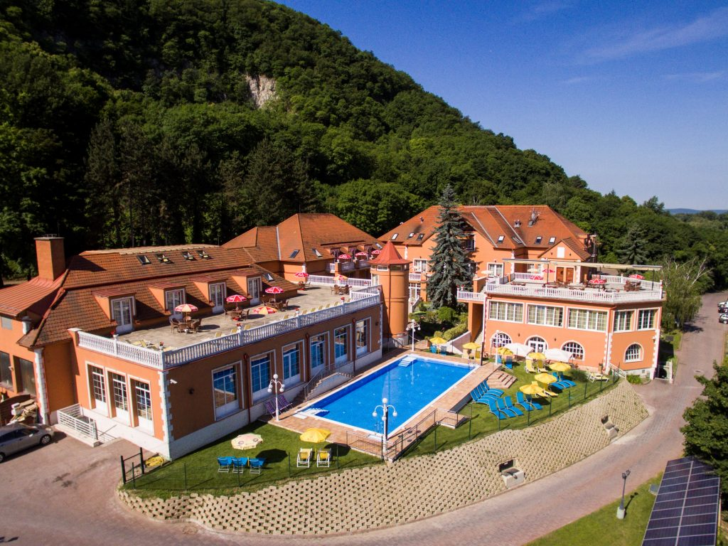
• Lurkó Kuckó for the little ones, X-Box room for the big ones,
• bathrobe for adults, towel preparation,
• free internet access,
• parking, VAT.
• The rooms can be occupied from 3 p.m. and please leave by 10:30 a.m. on the day of departure
• Tourist tax: above room rates do not include the tourist tax, which amount HUF 500/person/ night.
Payment methods: Bank card, cash, credit card and SZÉP card
You can find photos about the place of the competition, the wellness, the restaurant, the rooms on the website of Hotel Bellevue*** Esztergom: https://bellevuehotel.hu/galleries
We reserve the rights of the change in the notice of the competition.

We wait everyone to the event with love!

Registration, information:​
Jozsef Jeszenszky www.wellnesschesstour.com https://www.facebook.com/wellnesschesstour
Tournament director sporty207@gmail.com +36 30 640 3361

