Wellness Chess Tour 2025.
Hotel Aurora **** Miskolctapolca
-International Competition Series-
- Grand Prix competition 1st station –
- with wellness and half boarded foods-
January 16-19. 2025.
The competition’s goal: Providing an opportunity to participate in competitions and gain rating points.
Information that you have to know about our Grand Prix system:
I would like to reward your loyalty! On an annual level, in our competition series which consisting
12 stations by the actual station is 1-10. with our ranking, we get GP points, and with it, we have a good chance to win the +210,000 HUF total premium reward awarded at our final competition in December 2025! Those who participate at least 6 stations will be included in the absolute order of the GP table, and the final winners of this (1st-5th place in the table) will be awarded at our final competition in December 2025!
Anyone who participates in at least 10 of the 12 stations will receive a GUARANTEED Wellness weekend in a hotel of their choice for 2 people! (The 3 wellness weekends will be awarded to the three players who complete 10 stations the fastest and their partner/companion).
Location: Conference Room in Hotel Aurora **** Miskolctapolca
3519. Miskolctapolca, Fagyöngy street 2-4.
Competition’s date: 2025. January 16. – January 19. (Thursday - Sunday)
Schedule: Opening ceremony: January 16. 10:50
1st and 2nd rounds: January 16. 11:00 and 16:00
3rd and 4th rounds: January 17. 9.00 and 15.00
5th and 6th rounds: January 18. 9.00 and 15.00
FIDE Blitz competition: January 18. 19:30
7th round: January 19. 9.00
The closing ceremony is right after the end of the last round!
Competition’s form: 7 rounds, Swiss system, Open, no ELO restriction
Organizer: Jozsef Jeszenszky, registration: sporty207@gmail.com
Time limit: 1,5 hour – 1,5 hour + 30 sec per move bonus time
Entry fee: Above 2200 ELO: HUF 9.000, 2199 – 2100 HUF 12.000, under 2100 ELO: HUF 13.000, and free for GM, IM, WGM, WIM.
FIDE blitz tournament entry fee: HUF 3000
Discount: Those who participate in at least 6 stations will receive a 2000 HUF discount on the entry fee at each location from the 7th station in 2025!
If at least 5 paid people from a chess association are registered for our tournament, they will receive a fee discount per person! In the case of an entry fee of HUF 13,000, the player's entry fee will be HUF 11,000, if entry fee of HUF 12,000, it will be HUF 10,000 and if it is HUF 9,000, it will be HUF 8,000!
Entry information: Entry deadline: 15th January 2025. to the sporty207@gmail.com email address. All registrations will be confirmed. You can only enter the competition with a valid license or HPL for 2025.
Prize: Prize base: HUF 250.000! (guaranteed with at least 50 participants)
- HUF 100.000, 2. HUF 60.000, 3. HUF 35.000, 4. HUF 25.000, 5. HUF 20.000, 6. HUF 10.000.
- HUF 100.000, 2. HUF 60.000, 3. HUF 40.000, 4. HUF 30.000, 5. HUF 20.000. Special award for the best young competitor, the best competitor from Borsod County and the best competitor who is at least 60 years old and also the best woman (at least 3 players). Prizes (5-5000HUF) for the best competitor 1600-1800 ELO points and 1800-2000 ELO points. Prizes are not split. Taxes and contributions are according to Hungarian law!
Tiebreak: 1. Corrective Buchholz; 2. Buchholz 3. Progressive
Accommodation, special offer:
Hotel Aurora **** Miskolctapolca
Service: half-boarded generous buffet breakfast and generous dinner
Double room for 2 people: HUF 39,990 / room for 2 people / night

Double room for 1 person: HUF 24,990 / room for 1 person / night

Surcharge for extra bed (sofa): free of charge for ages 0-5

Child discount: under 6 years free! 6-12 years old HUF 14,950 / person / night

The above price includes the following:

Accommodation in a double room for 1 or 2 people
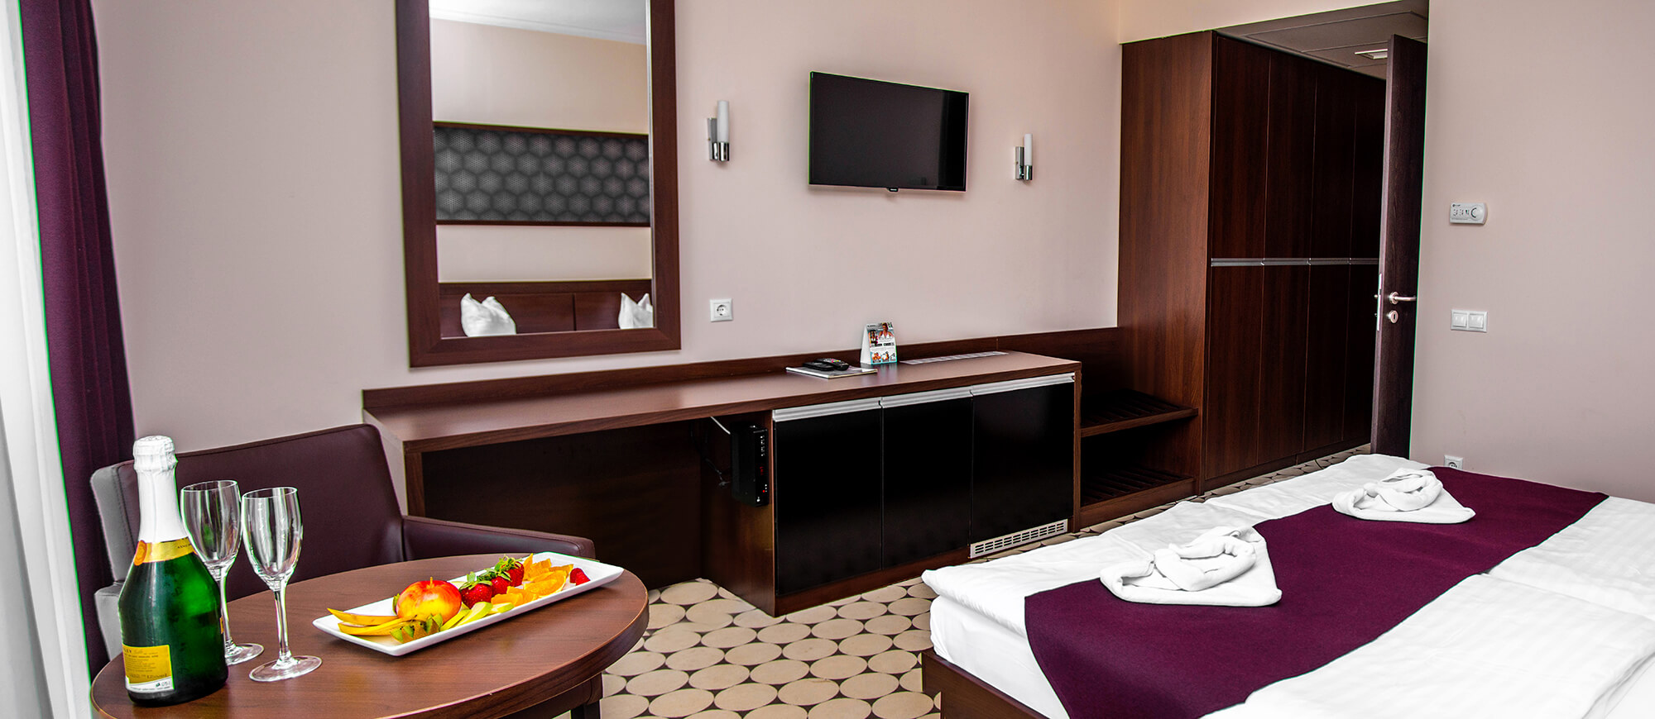
Half-board (extended continental breakfast and multi-course dinner from the buffet, without drinks)

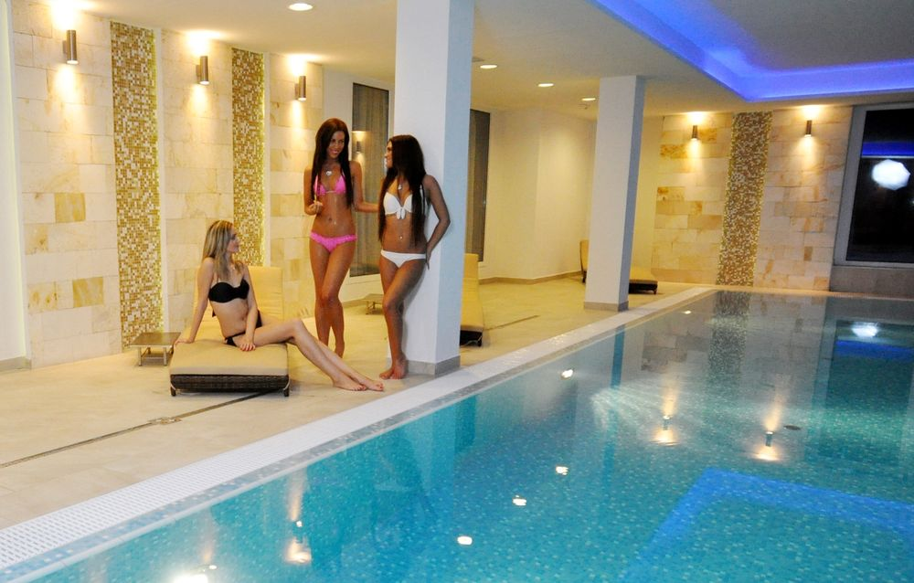
Unlimited use of wellness and spa area (8:00-21:00): 26°C heated indoor swimming pool, 34°C sparkling pool with massage elements, Finnish sauna, infrared cabin, salt cabin,
Preparing a bathrobe,

number combination room safe,
bathroom with hairdryer,
wireless Internet
VAT.

Parking: - in an outdoor, camera-monitored parking lot: HUF 1,200 / car / night
- in an underground garage HUF 2,000 / car / night
- in the public parking lot in Miskolctapolca: free of charge
The accommodation price does not include tourist tax.
You can find photos about the place of the competition, the wellness, the restaurant, the rooms on the website of Hotel Aurora Miskolctapolca: https://hotelaurora.hu/galeria

You can check-in and book the rooms 14 o’clock at the day of the competition, and have to leave until 10 o’clock at the last day.
We reserve the rights of the change in the notice of the competition.

We wait everyone to the event with love!
Nomination, information:​
Jozsef Jeszenszky Tournament director sporty207@gmail.com +36 30 640 3361
www.wellnesschesstour.com https://www.facebook.com/wellnesschesstour

